College and Military Reps Lunch Visits
9/15: Marines
9/28: Northwood University –FIRST LUNCH ONLY* in the library
9/29: Army
10/4: Lawrence Technological University
10/5: Madonna University
10/10: University of Toledo-Free Application Workshop with UT Representative in Student Lounge
10/11: National Guard
10/12: Monroe County Community College
10/17: Eastern Michigan University
10/18: University of Michigan in the library
10/20: Marines
10/24: Air Force
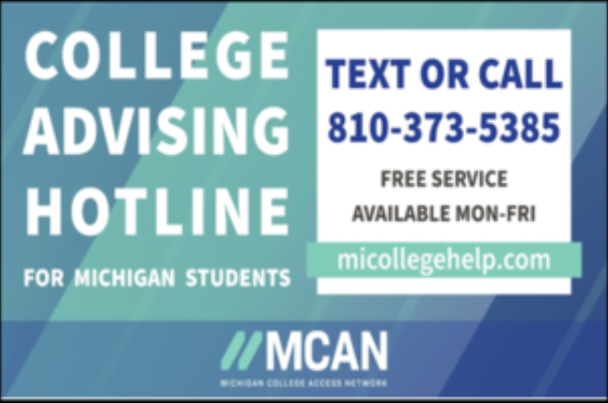
10/26: Oakland University
11/14: Mercy College of Ohio

