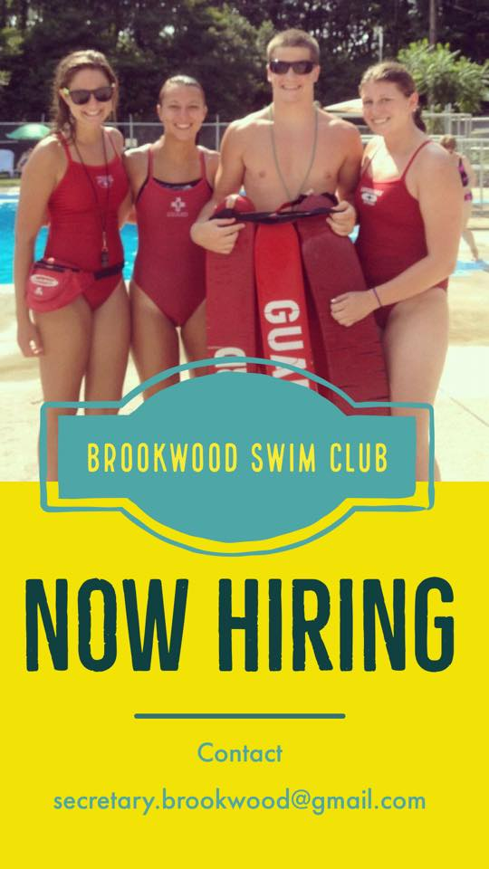

Pssst...we’re hiring!
Snow days are a great time to work on job applications! Our staff is required to be certified in American Red Cross Lifeguarding Skills, First Aid, and CPR. Certification classes take place over the winter and typically fill up quickly, so now is the time to start researching and get signed up!
If you have been a Brookwood employee and would like to return for Summer 2020, please contact us ASAP!

secretary.brookwood@gmail.com

